FUNDAMENTAL OF COMPUTER PROGRAMMING

LAB_03

NAME: HANAN MAJEED

CMS ID: 519166

CLASS : BSDS_02_A

[Company name]  [Company address]

**Task A:**

For each of the following arithmetic expressions, manually calculate the result and put it in the Answer box given below. Afterward, execute the expression in C++ and verify your answers. If your answer is not the same as the one given by C++, provide a reason for that.

* 1. 9 - 3
  2. 8 * 2.5
  3. 9 / 2
  4. 9 / -2
  5. 9 / -2.0
  6. 9 % 2
  7. 9.0 % 2
  8. 9 % -2
  9. -9 % 2
  10. 4 + 3 * 5
  11. (4 + 3) * 5

Solution:

|  |  |  |  |
| --- | --- | --- | --- |
| **Expression** | **Estimation** | **C++ Result** | **Remarks** |
| a | **6** | **6** |  |
| b | **20** | **20** |  |
| c | **4.5** | **4** | **.5 in not included** |
| d | **-4.5** | **-4** | **.5 is not included** |
| e | **-4.5** | **-4.5** |  |
| f | **1** | **1** |  |
| g | **1** |  | error C2296: '%' : illegal, left operand has type 'double' |
| h | **-1** | **1** | **(-) sign in not included** |
| i | **1** | **-1** | **(-) sign is included** |
| j | **19** | **19** |  |
| k | **35** | **35** |  |

TASK B:

INPUT:

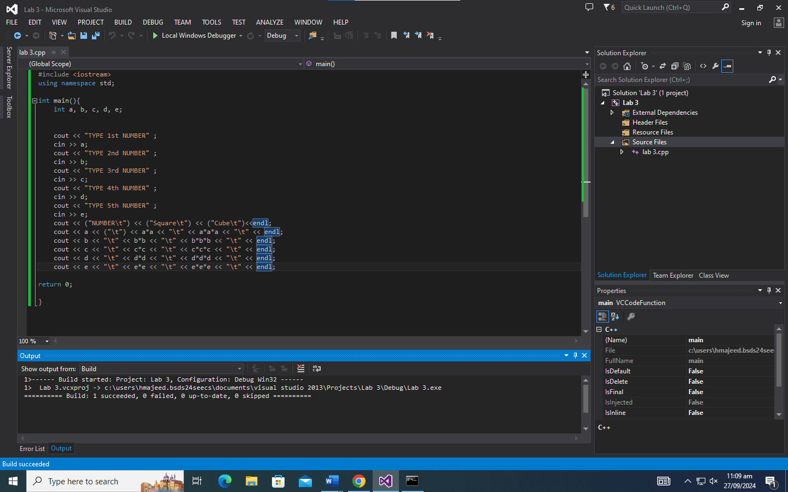

OUTPUT:

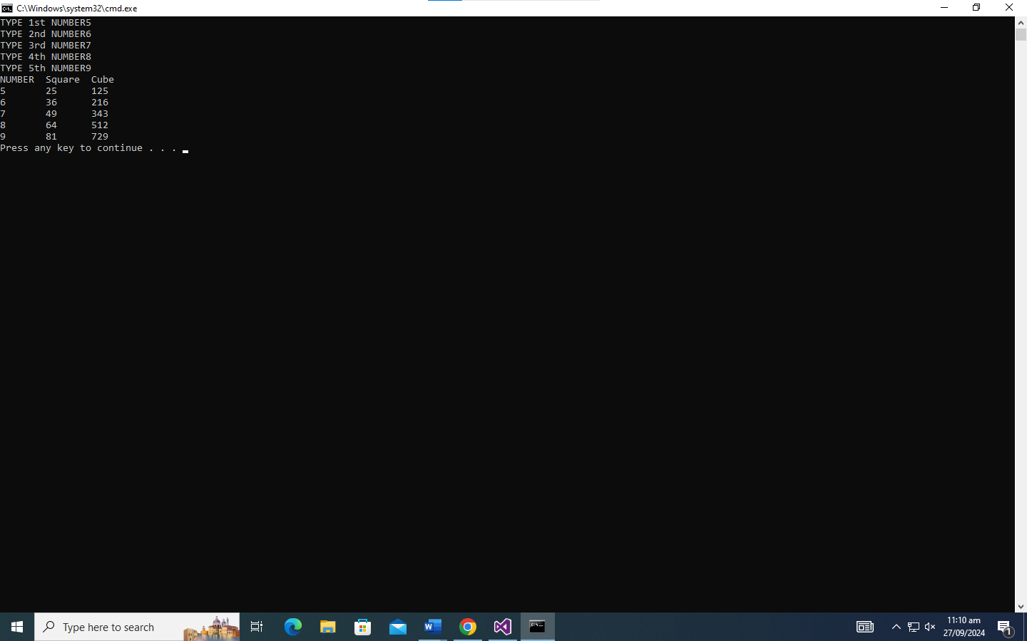

TASK C:

INPUT:

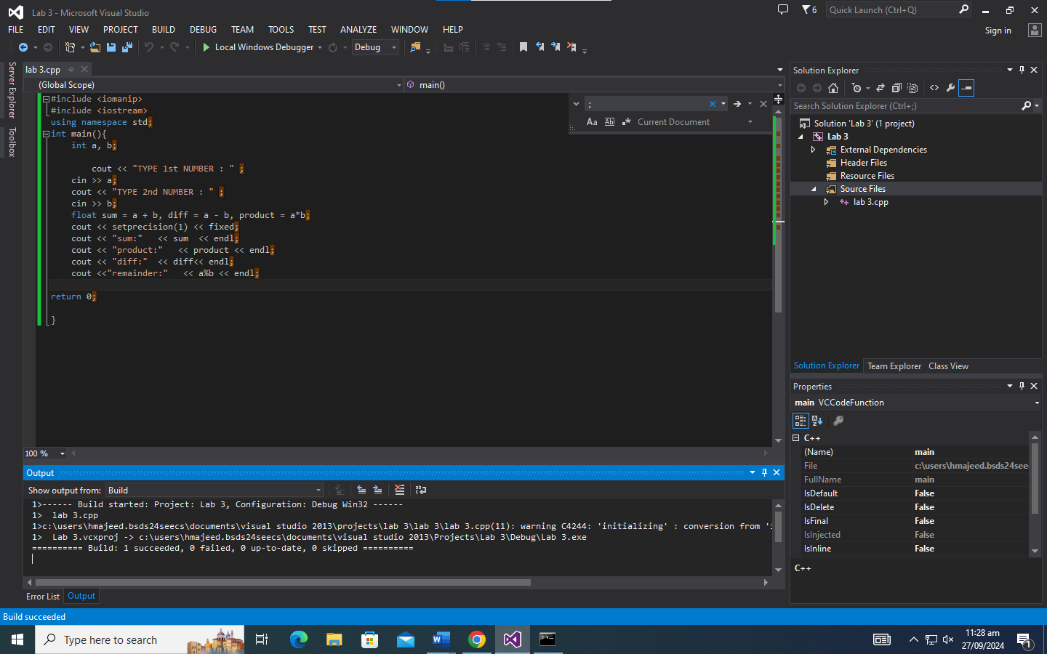

OUTPUT:

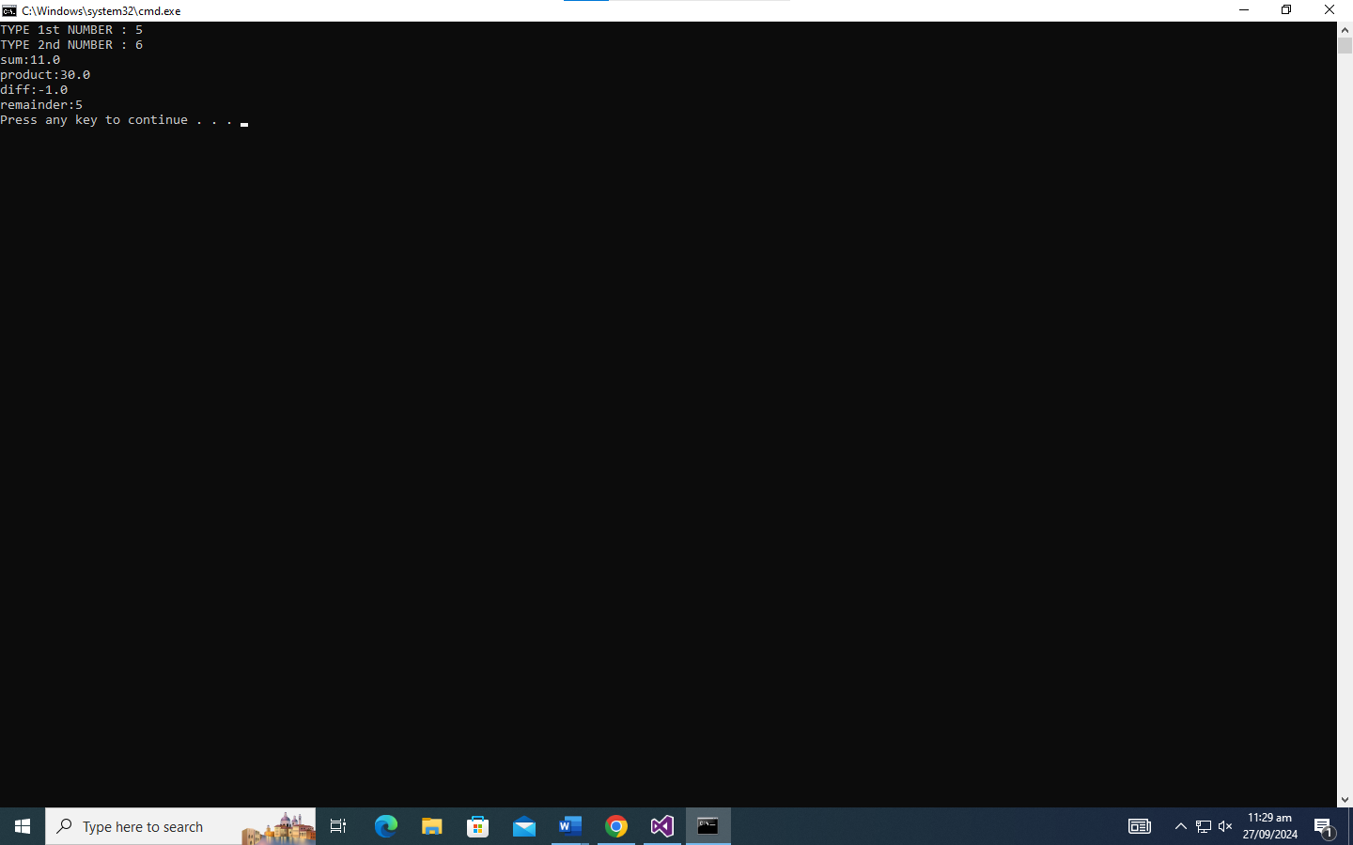

TASK D:

INPUT:

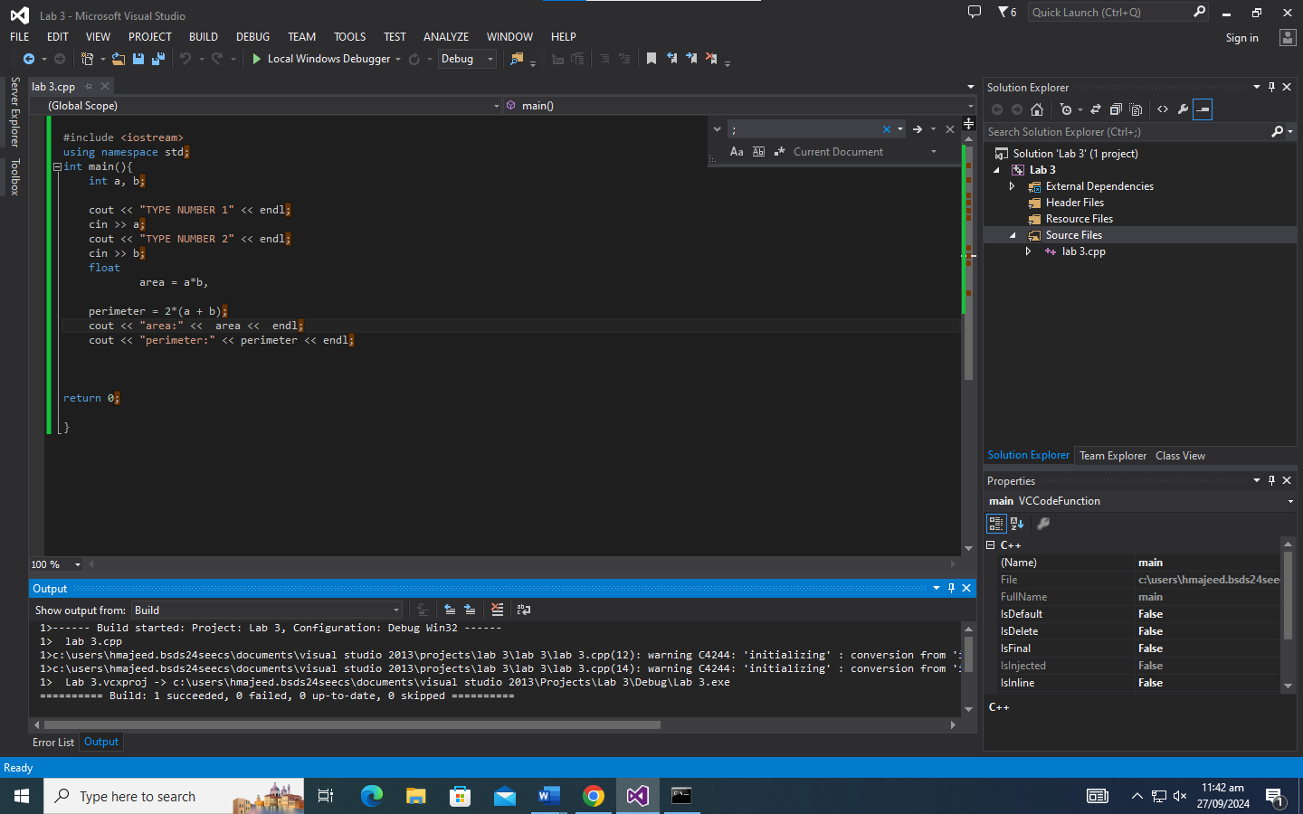

OUTPUT:

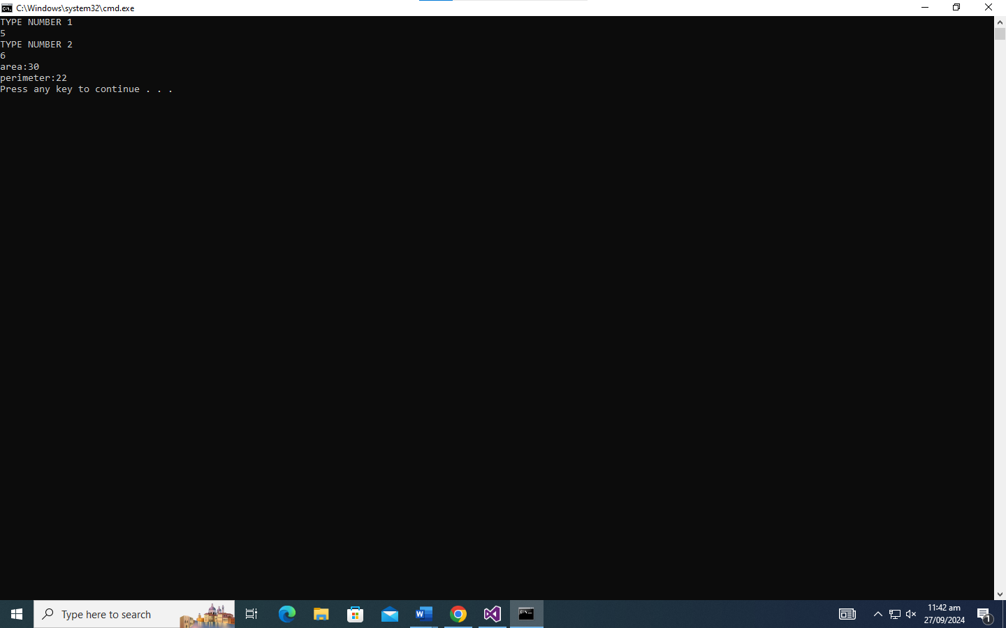

TASK E:

INPUT:

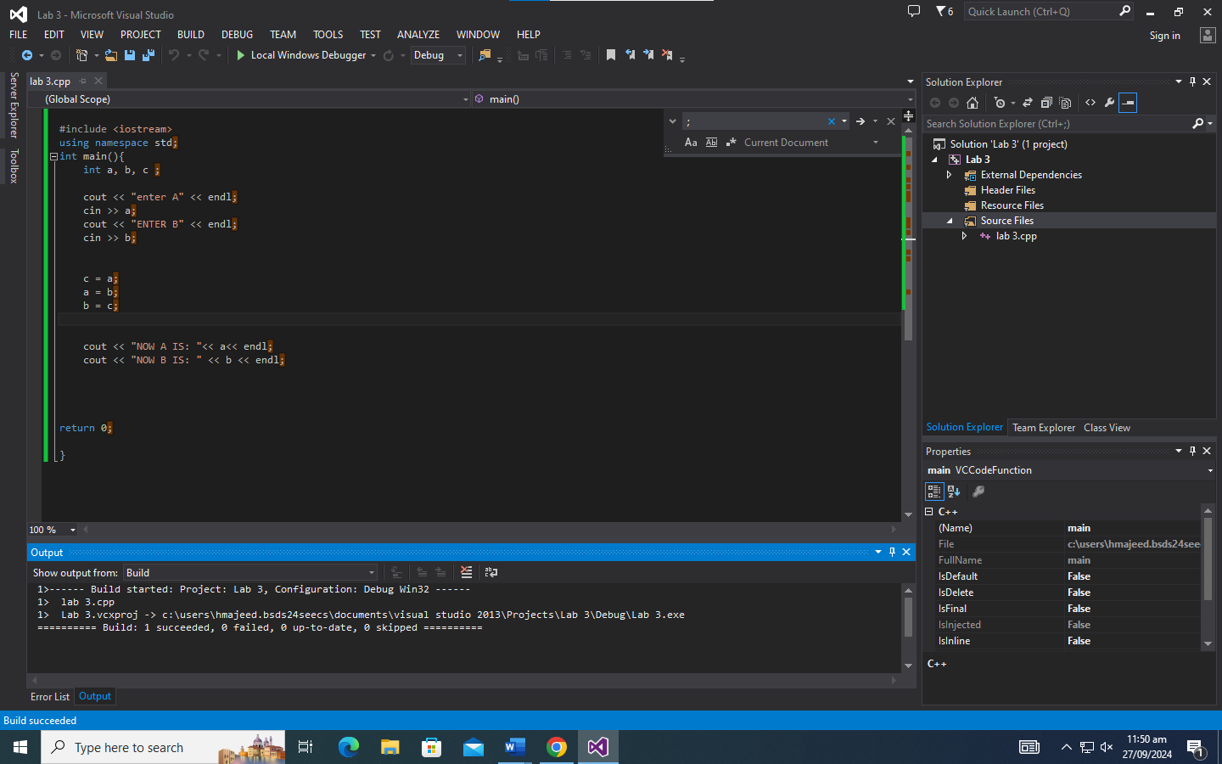

OUTPUT:

